**Java Day 5**

1. **Create a new Excel Workbook** 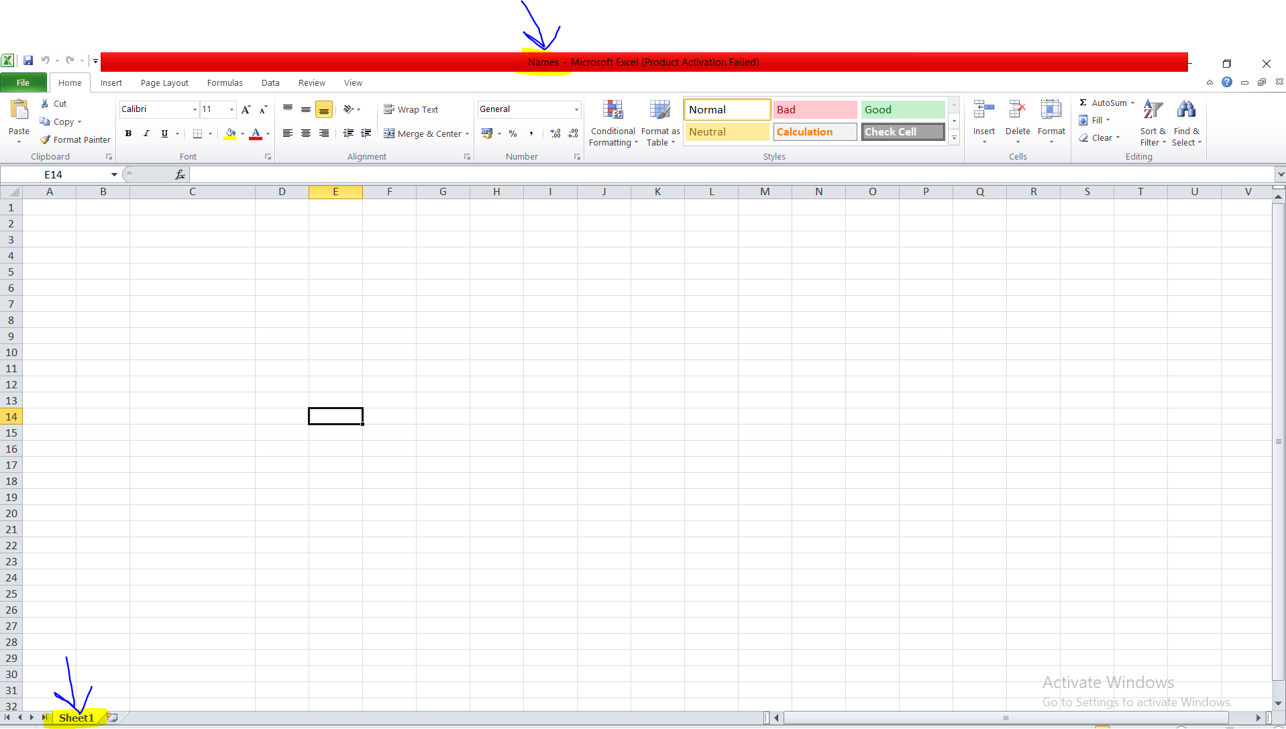
2. **Create a new sheet name as Sheet1**



1. **Write the data into the code**

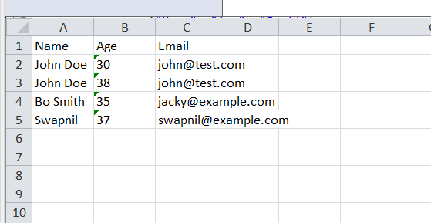

1. **Write the data via code**

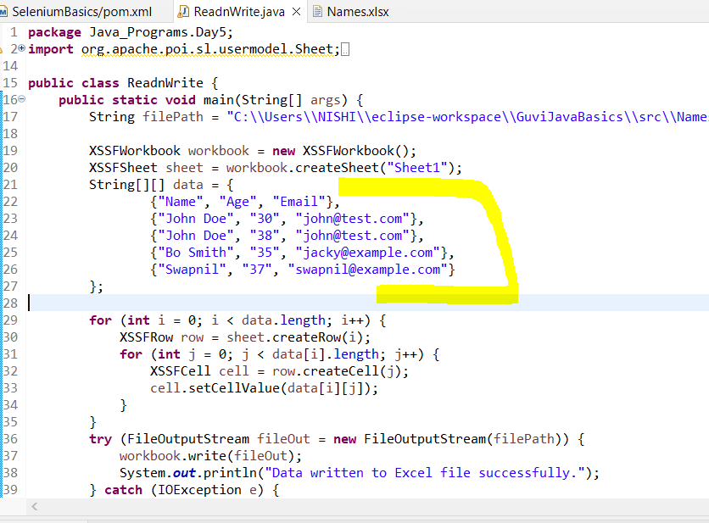

1. **Read the data via code**

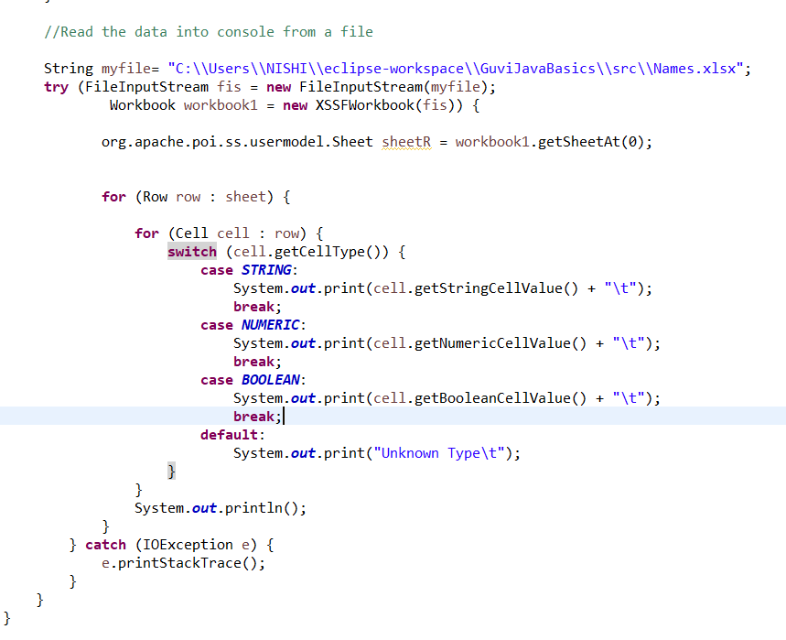

**Output:-**

